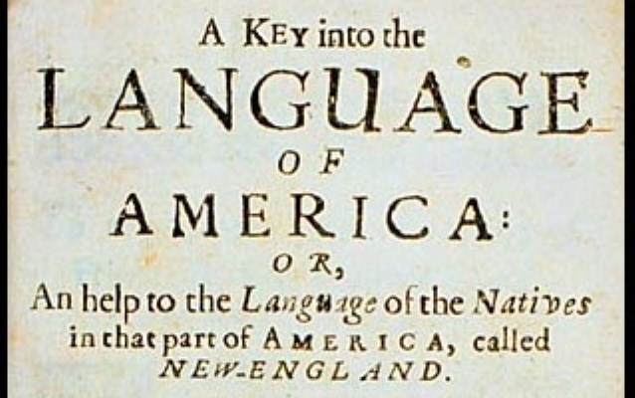
What does Roger Williams’ “Key” unlock?
Group Member Names: ___________________________________________________
Answer with your group:
- What surprised you about your chapter?

- Give an example and describe a “key” from your reading that would have been helpful to the English. This key can be a term, idea, phrase, or advice.

- What insight did your chapter reveal about the Native Americans?

- As a colonist, how might you have used these insights?

Answer with members of the other groups:
What insights or key information did the chapters reveal about Native Americans in all of the chapters?

How could the colonists have used the insights in daily life?

How could the colonists have used the insights
in work and business?

How could the colonists have used the insights in building relationships with Native Americans?

